Gayatri Mishra | https://www.linkedin.com/in/gayatri-mishra-freelancecoach/
Day- 1 Scenarios | Postman Training
Scenario – 1:
Install postman in windows 11.
Scenario – 2:
Checkout the interface or ui of postman .
Scenario – 3:
Check the postman web.
Scenario – 4:
Execute the first Get method for api reqres.in

Gayatri Mishra | https://www.linkedin.com/in/gayatri-mishra-freelancecoach/

Day- 2 Scenarios | Postman Training

Scenario -1 :
Case study reqres.in
Create a collection named as YourName_Postman_Day1
Create a get request tc_001_getreq
https://reqres.in
end point : /api/users?page=2
Execute the get request .
Get the response code.
Get the response body.
Scenario – 2:
Execute the post request .
https://reqres.in/api/users
End point :
/api/users
Method POST
Request body :
{
"name": "morpheus",
"job": "leader"
}

Response body:
{
"name": "morpheus",
"job": "leader",
"id": "356",
"createdAt": "2024-03-21T18:29:56.953Z"
}

Gayatri Mishra | https://www.linkedin.com/in/gayatri-mishra-freelancecoach/
Get the response code.
Get the response body.
Validate the response code.
Validate the response body.
Scenario – 3:
Launch the postman web.
Launch your work space .
Get the key for your Collection .
Get the keys for your requests.
Scenario – 4:
Create a new request and
Execute scenario – 2 by passing the body in external file.
Testbody.json
Testbody1.txt
Both must work.
Normal body area must be blank.

Scenario – 5:
Execute the entire collection from postman cli.
Step-1
Command to install postman cli in windows 11:
powershell.exe -NoProfile -InputFormat None -ExecutionPolicy AllSigned -Command "[System.Net.ServicePointManager]::SecurityProtocol = 3072; iex ((New-Object System.Net.WebClient).DownloadString('https://lnkd.in/dhVmfFuf'))"
Note: Just open your command prompt and copy paste the entire command and hit enter .
Step-2
Generate the postman api key using below link :
https://lnkd.in/dz2QvxDu
Step-3
Gayatri Mishra | https://www.linkedin.com/in/gayatri-mishra-freelancecoach/
Login command:
postman login <apikey>
Step-4
To execute the existing collection ...
Get the collection key from POSTMAN web .
postman collection run <>
s

Gayatri Mishra | https://www.linkedin.com/in/gayatri-mishra-freelancecoach/

Day- 3 Scenarios | Postman Training
Scenario-1:
Get the Bearer token for github .
Set the Bearer token in collection level.
Get different endpoints for github app from official github api to perform below
- Get the info for a single repos
/repos/c11472/AWS_SelfLearning_Content_2024
- Get the list of repos
/users/c11472/repos
- Create a new repository
/user/repos
Api body:
{"name":"Training Postman API Day2"}

- Delete the existing repos
/repos/c11472/Training-Postman-API-Day2

Scenario – 2
Restapi’s end points for github app.
https://docs.github.com/en/rest/authentication/endpoints-available-for-github-app-installation-access-tokens?apiVersion=2022-11-28#repos
Execute all the above with proper end points and get the response code and response body.

Gayatri Mishra | https://www.linkedin.com/in/gayatri-mishra-freelancecoach/

Day- 4 Scenarios | Postman Training
Scenario-1
Basic Authorization:
https://httpbin.org/basic-auth/example_username/example_password
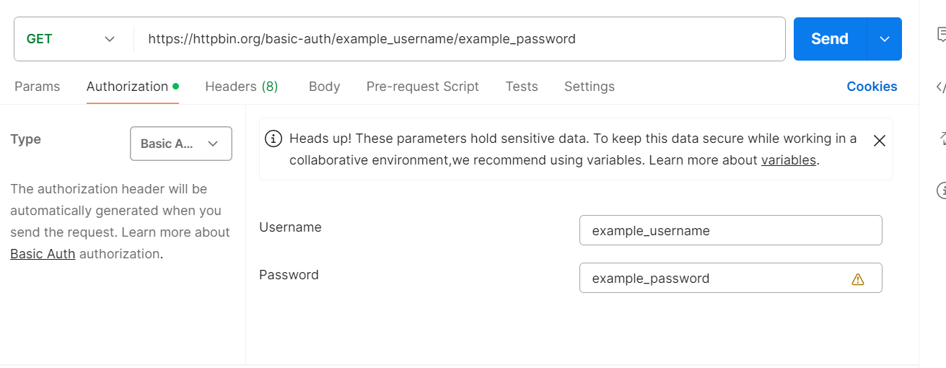

Scenario-2 :
OAuth 1.0
https://postman-echo.com/oauth1
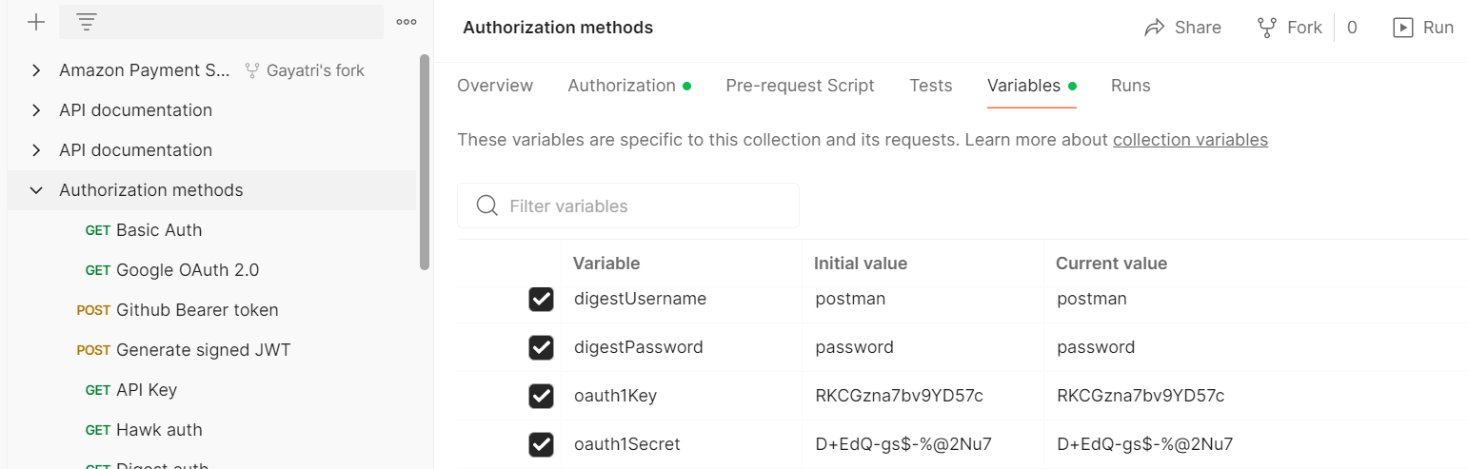

Gayatri Mishra | https://www.linkedin.com/in/gayatri-mishra-freelancecoach/

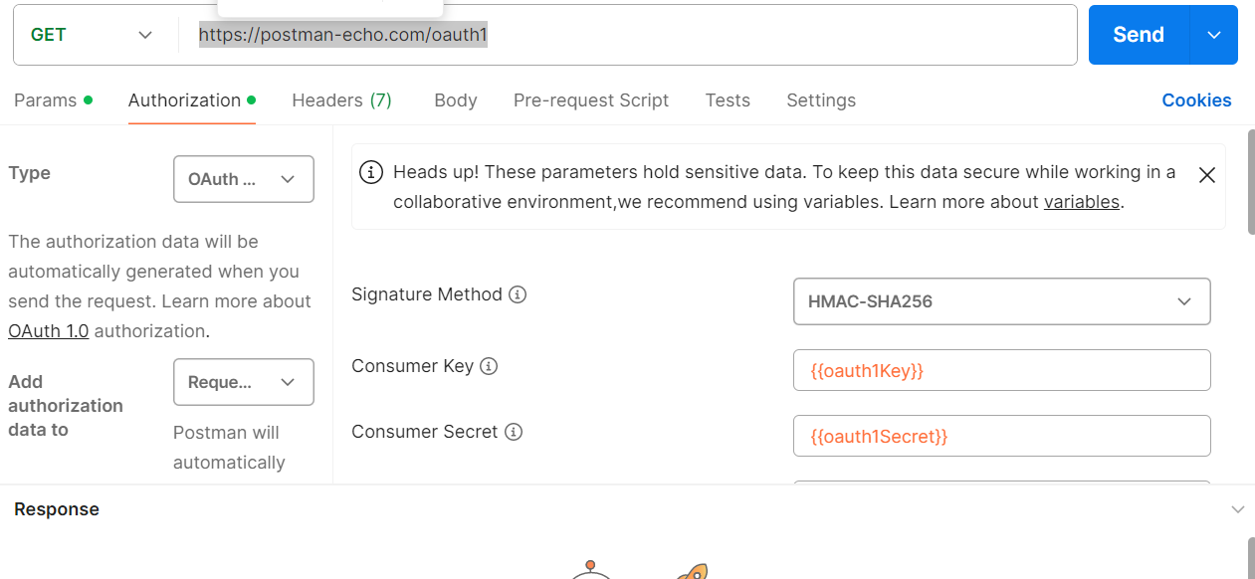
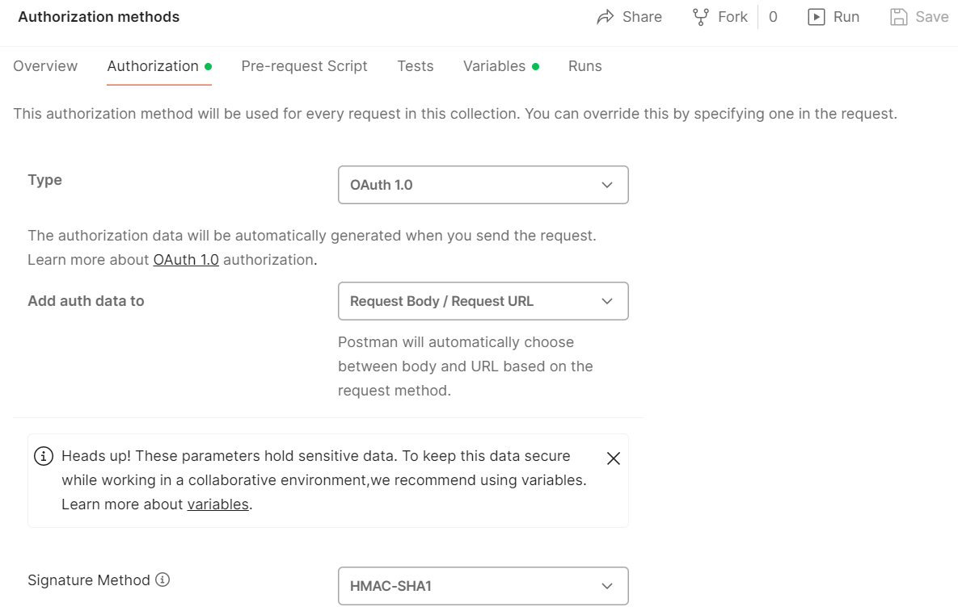

Gayatri Mishra | https://www.linkedin.com/in/gayatri-mishra-freelancecoach/

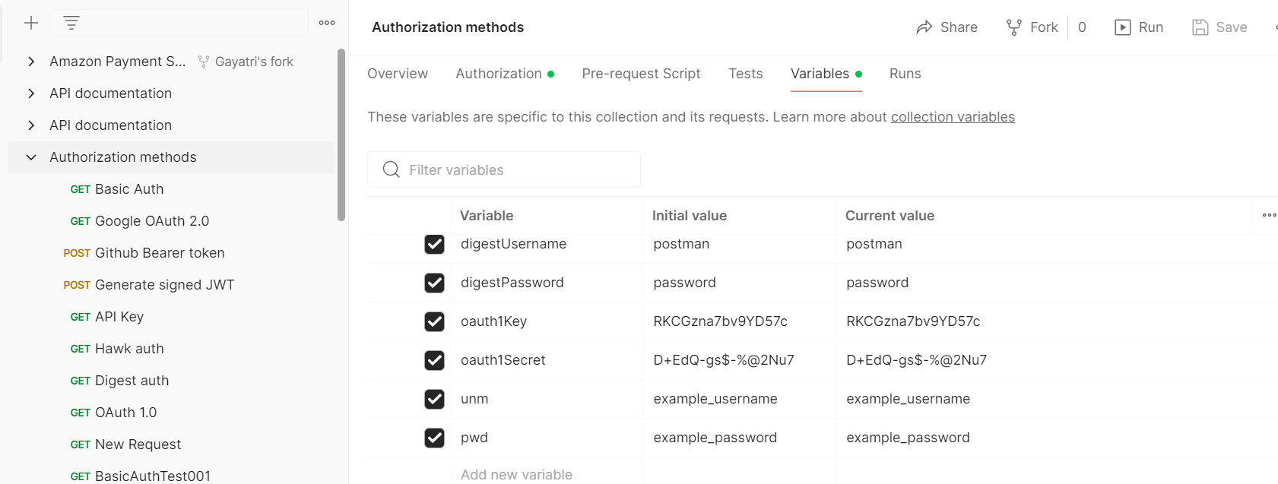

Day- 5 Scenarios | Postman Training
Iterations & Delay

Scenario-1:
Get the Bearer token for github .
Set the Bearer token in collection level.
Get different endpoints for github app from official github api to perform below
- Get the info for a single repos
/repos/c11472/AWS_SelfLearning_Content_2024
- Get the list of repos
/users/c11472/repos
- Create a new repository
/user/repos
Api body:
{"name":"Training Postman API Day2"}

Gayatri Mishra | https://www.linkedin.com/in/gayatri-mishra-freelancecoach/

- Delete the existing repos
/repos/c11472/Training-Postman-API-Day2
Go to collection .
Click on Run
Change the iteration from 1 to 3.
Change delay to 3000 ms i.e 3 seconds.
Execute the commands.
Extract the response body and capture the report.

Scenario – 2:
Working with test in postman.
Exercise for writing the first test in postman for a single get Request
Github api:

End point:
GET /repos/{owner}/{repo}
https://api.github.com/Get/repos/c11472/testsample

Execute the get request .
Write the test to validate the response code.

Steps to write the test:
- Select the request
- Click on test
- Add the below code .. to validate the response code dynamically.
Gayatri Mishra | https://www.linkedin.com/in/gayatri-mishra-freelancecoach/

pm.test("Check response status code of testcase_getrepos_01", function () {
pm.response.to.have.status(201); // checl point
});

pm.test("Check response status code of testcase_getrepos_01- test2", function () {
pm.response.to.have.status(400); // checl point
});

pm.test("Check response status code of testcase_getrepos_01", function () {
pm.response.to.have.status(200); // checl point
});

pm.test("Check response status code of testcase_getrepos_01-test3", function () {
pm.response.to.have.status(350); // checl point
});

Click on send to execute.
Access test result tab to view the report.

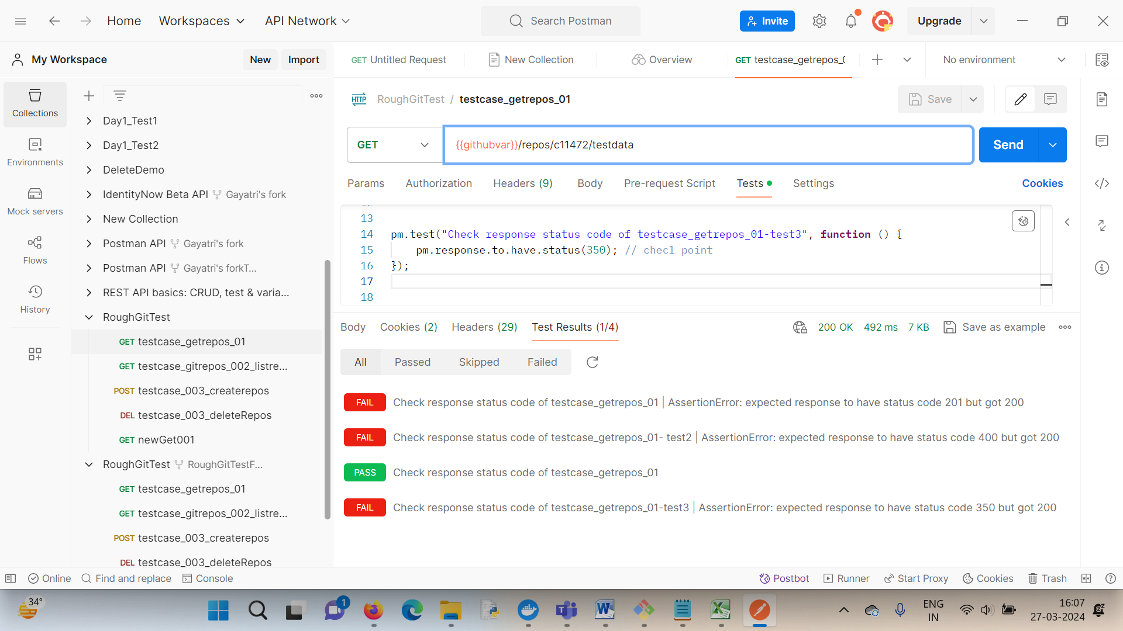

Gayatri Mishra | https://www.linkedin.com/in/gayatri-mishra-freelancecoach/

Day- 6 Scenarios | Postman Training
Scenario – 1:
Data driven testing
API Base URI : https://reqres.in
End point : /api/users
Method : POST
Create the set of test data in JSON file.
Save the file in collection runner level.
Execute the collection using Run Collection in Collection runner .
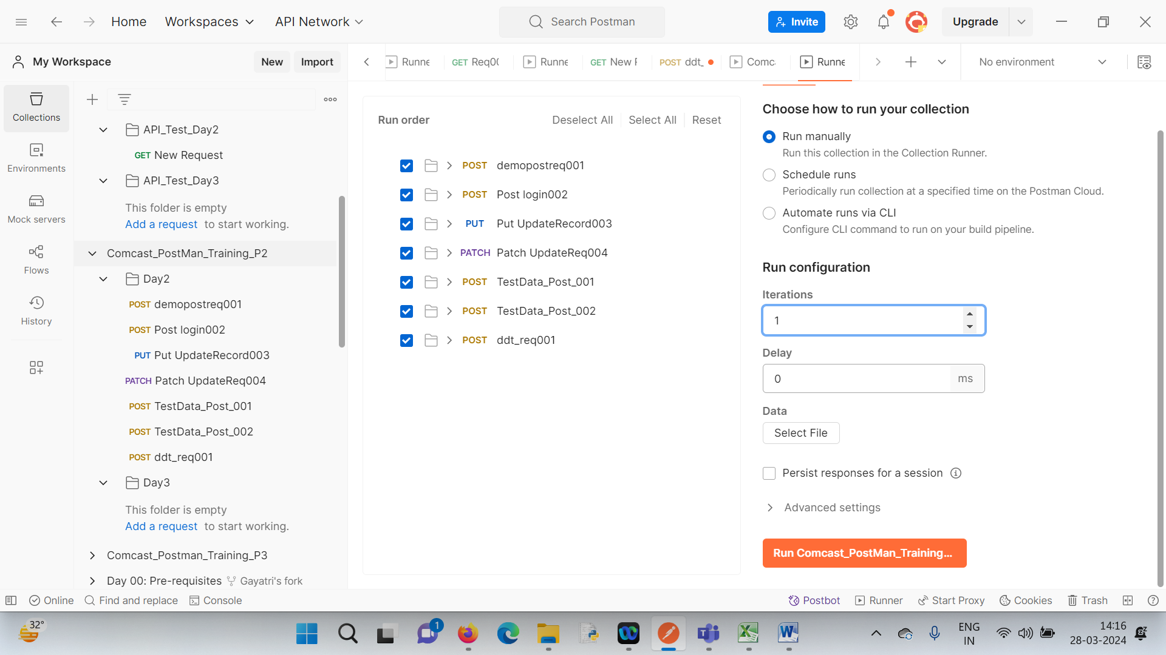

Gayatri Mishra | https://www.linkedin.com/in/gayatri-mishra-freelancecoach/

Scenario – 2:
Data conversion tool:
https://data.page/json/csv

https://csvjson.com/csv2json
Scenario – 3:
Writing test for response body validation.
https://learning.postman.com/docs/writing-scripts/script-references/test-examples/#test-response-body
Scenario – 4:
Collection – Generate test
Execute and check all set of auto generated validation codes test with execution status.

Scenario – 5:
Select 3 different requests from collection and execute only those except others.

Day- 7 Scenarios | Postman Training
Scenario – 1:
Sample performance testing execution and report analysis
Step-1: Right click on collection and click on run collection
Step-2 : Click on Performance

Gayatri Mishra | https://www.linkedin.com/in/gayatri-mishra-freelancecoach/

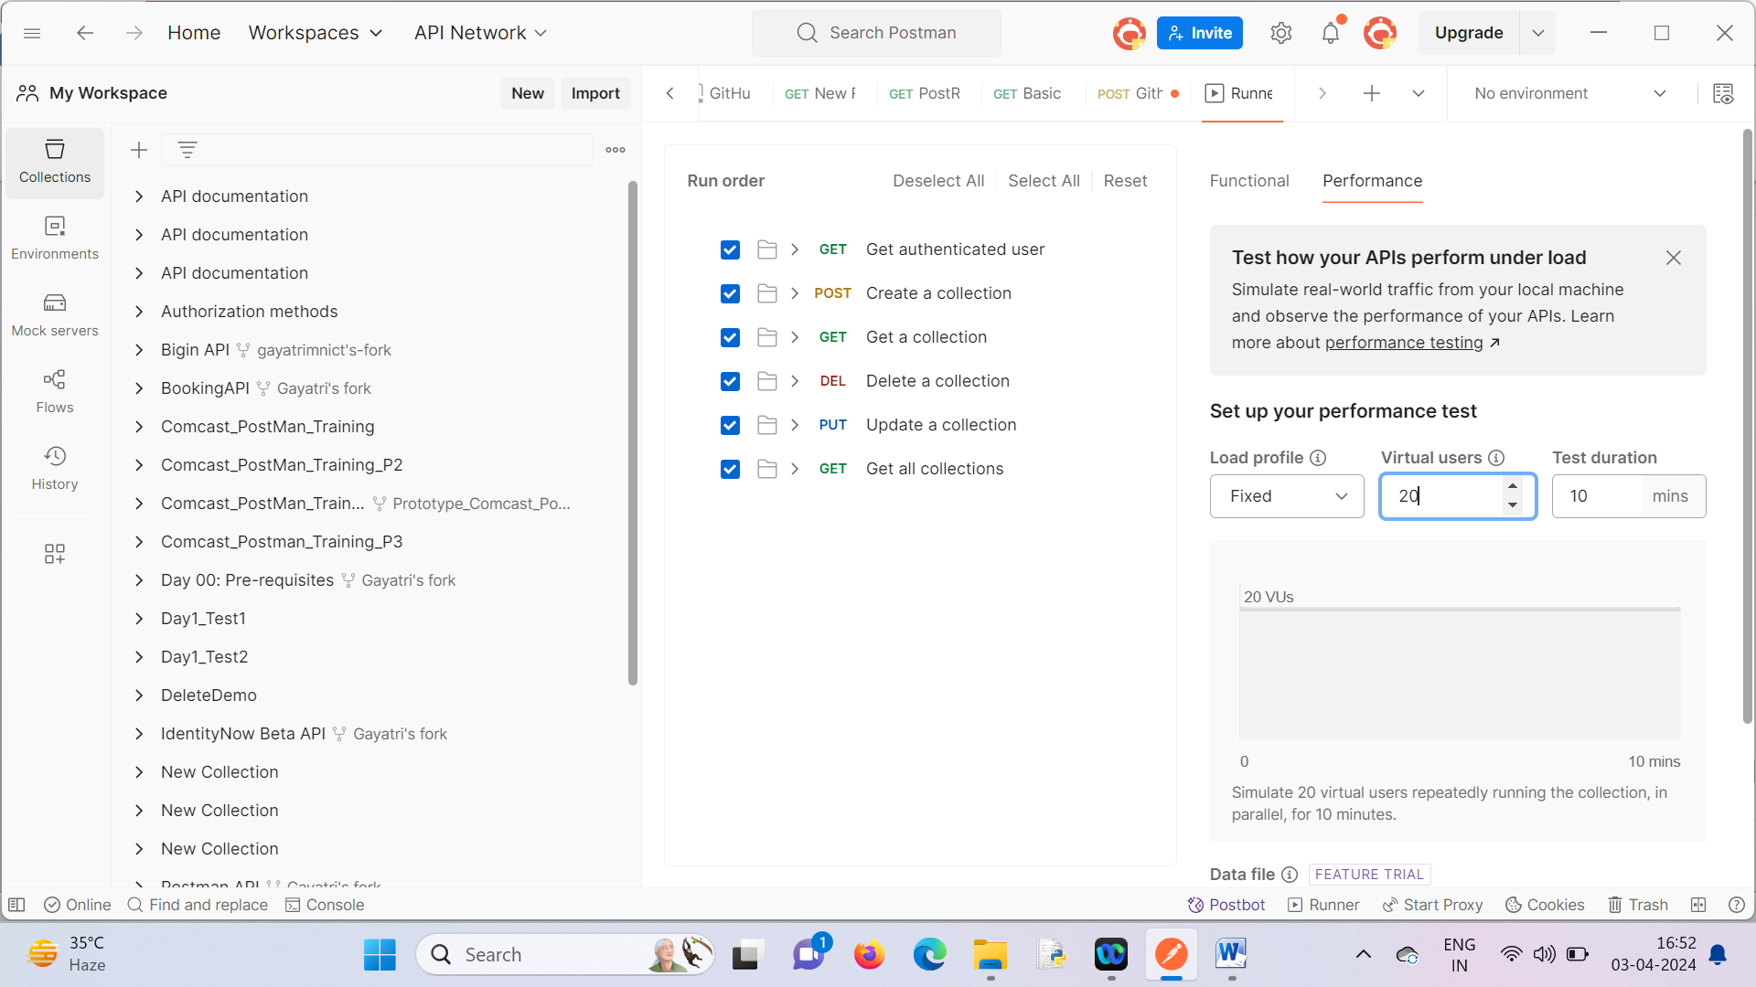
Change the Load profile
Change virtual users
Change Test duration
Select the data file if required
Click on run.

Gayatri Mishra | https://www.linkedin.com/in/gayatri-mishra-freelancecoach/

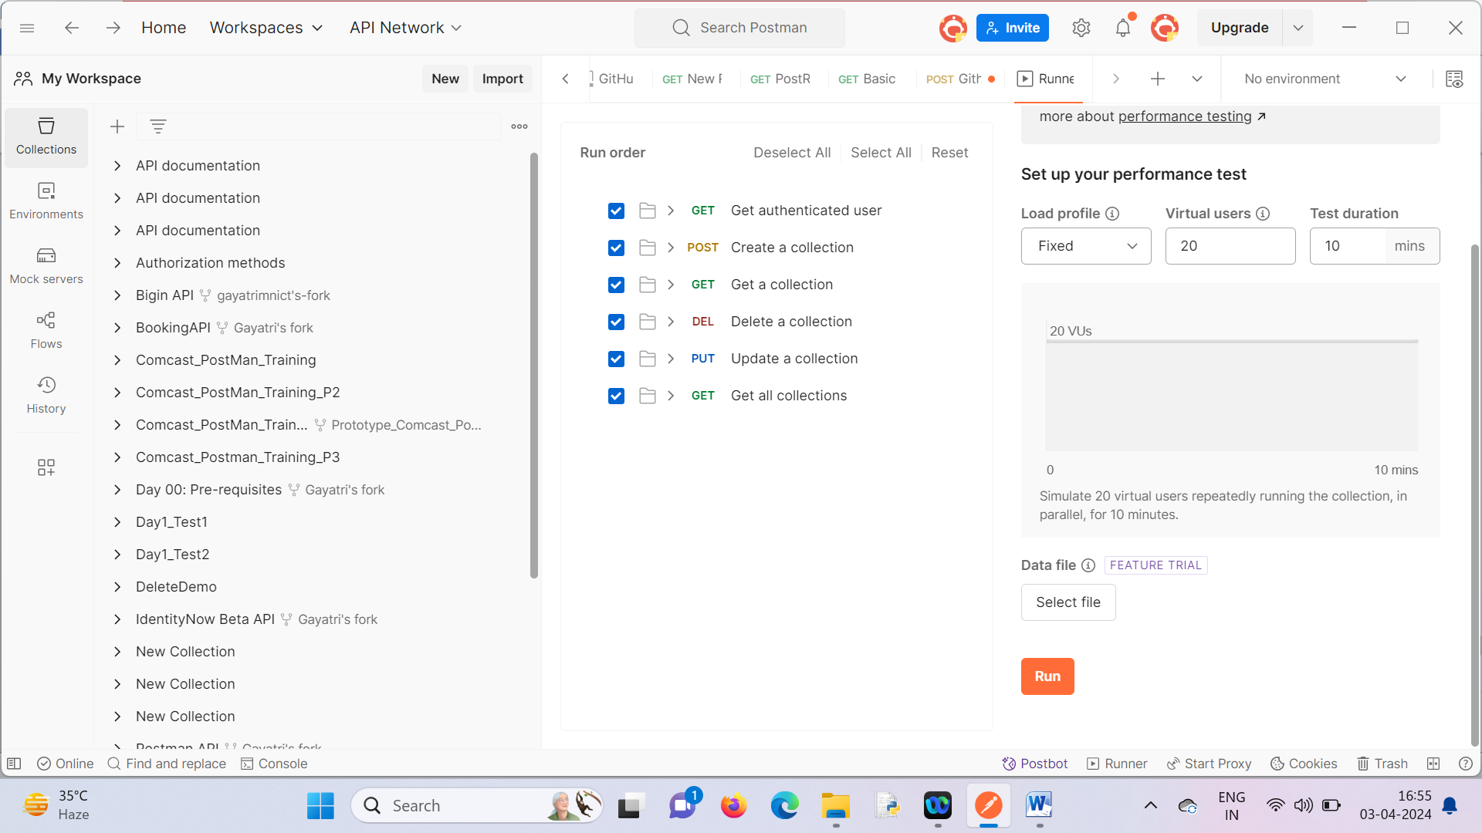
Scenario – 2:
Install Newman.
Execute the collection using newman :
Steps :
- Export the collection to json file and keep in local drive.
- Open command prompt and execute the command..
newman run E:/Comcast_PostMan_Training_P2.postman_collection.json

Gayatri Mishra | https://www.linkedin.com/in/gayatri-mishra-freelancecoach/

